CREATE TABLE ipl_matches (

match_id INT PRIMARY KEY AUTO_INCREMENT,

season YEAR NOT NULL,

match_date DATE NOT NULL,

venue VARCHAR(100),

-- Team 1 information

team1_id INT,

team1_name VARCHAR(50),

team1_city VARCHAR(50),

team1_captain_id INT,

team1_captain_name VARCHAR(100),

-- Team 2 information

team2_id INT,

team2_name VARCHAR(50),

team2_city VARCHAR(50),

team2_captain_id INT,

team2_captain_name VARCHAR(100),

-- Match results

toss_winner_id INT,

toss_decision VARCHAR(10),

match_winner_id INT,

win_by_runs INT,

win_by_wickets INT,

-- Player of the match

player_of_match_id INT,

player_of_match_name VARCHAR(100),

player_batting_style VARCHAR(50),

player_bowling_style VARCHAR(50),

-- Batting performance (for player of match)

runs_scored INT,

balls_faced INT,

fours INT,

sixes INT,

strike_rate DECIMAL(5,2),

-- Bowling performance (for player of match)

overs_bowled DECIMAL(3,1),

runs_conceded INT,

wickets_taken INT,

maidens INT,

economy_rate DECIMAL(5,2)

);

-- Sample data for 5 matches

INSERT INTO ipl_matches VALUES

(1, 2023, '2023-04-09', 'Wankhede Stadium',

1, 'Mumbai Indians', 'Mumbai', 101, 'Rohit Sharma',

2, 'Chennai Super Kings', 'Chennai', 102, 'MS Dhoni',

1, 'bat', 1, 15, NULL,

101, 'Rohit Sharma', 'Right-handed', 'Right-arm offbreak',

65, 45, 5, 3, 144.44,

NULL, NULL, NULL, NULL, NULL),

(2, 2023, '2023-04-10', 'M. Chinnaswamy Stadium',

3, 'Royal Challengers Bangalore', 'Bangalore', 103, 'Virat Kohli',

4, 'Kolkata Knight Riders', 'Kolkata', 104, 'Andre Russell',

3, 'field', 4, NULL, 6,

104, 'Andre Russell', 'Right-handed', 'Right-arm fast',

80, 40, 4, 8, 200.00,

4.0, 35, 2, 0, 8.75),

(3, 2023, '2023-04-11', 'Eden Gardens',

4, 'Kolkata Knight Riders', 'Kolkata', 104, 'Andre Russell',

5, 'Delhi Capitals', 'Delhi', 105, 'Rishabh Pant',

5, 'bat', 5, 25, NULL,

105, 'Rishabh Pant', 'Left-handed', NULL,

78, 50, 6, 4, 156.00,

NULL, NULL, NULL, NULL, NULL),

(4, 2023, '2023-04-12', 'Arun Jaitley Stadium',

5, 'Delhi Capitals', 'Delhi', 105, 'Rishabh Pant',

1, 'Mumbai Indians', 'Mumbai', 101, 'Rohit Sharma',

1, 'field', 5, NULL, 7,

106, 'Jasprit Bumrah', 'Right-handed', 'Right-arm fast',

NULL, NULL, NULL, NULL, NULL,

4.0, 18, 4, 1, 4.50),

(5, 2023, '2023-04-13', 'M. A. Chidambaram Stadium',

2, 'Chennai Super Kings', 'Chennai', 102, 'MS Dhoni',

3, 'Royal Challengers Bangalore', 'Bangalore', 103, 'Virat Kohli',

2, 'bat', 2, 12, NULL,

102, 'MS Dhoni', 'Right-handed', 'Right-arm medium',

42, 28, 3, 2, 150.00,

NULL, NULL, NULL, NULL, NULL);

Output: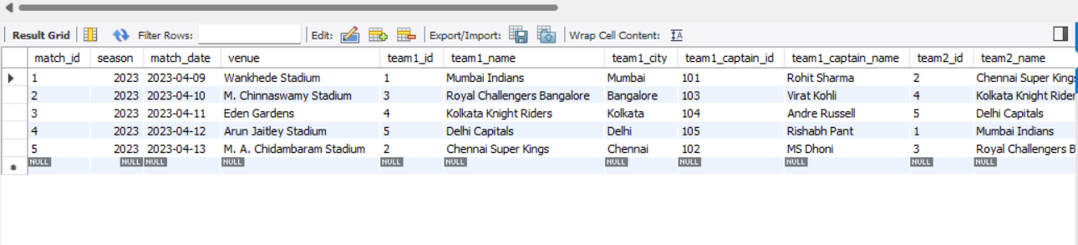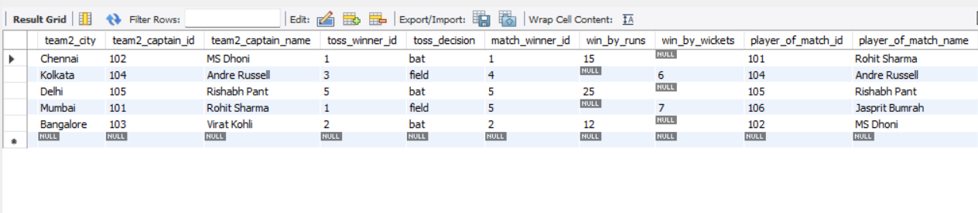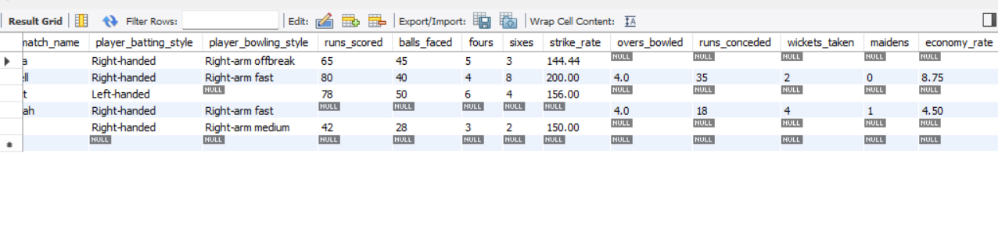

Queries:-

SELECT player_name, batting_style, bowling_style

FROM players

WHERE team_id = (SELECT team_id FROM teams WHERE team_name = 'Mumbai Indians')

ORDER BY player_name;

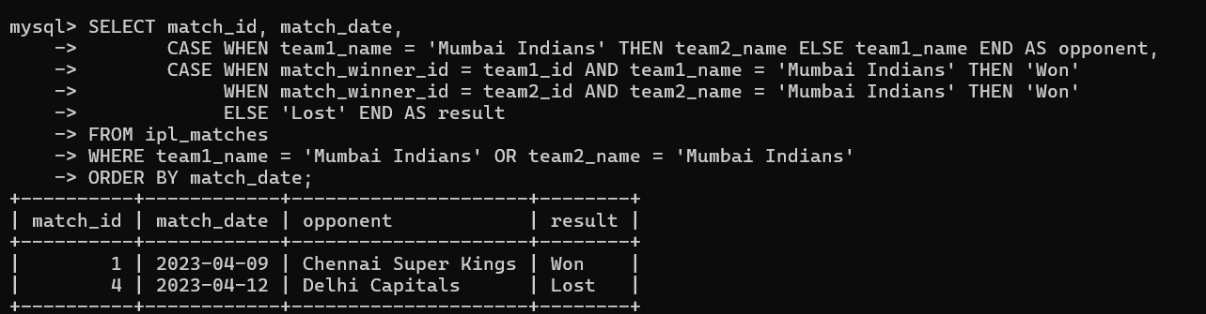

SELECT m.match_id, t1.team_name AS team1, t2.team_name AS team2, m.win_by_runs

FROM matches m

JOIN teams t1 ON m.team1_id = t1.team_id

JOIN teams t2 ON m.team2_id = t2.team_id

WHERE m.win_by_runs > 20

ORDER BY m.win_by_runs DESC;

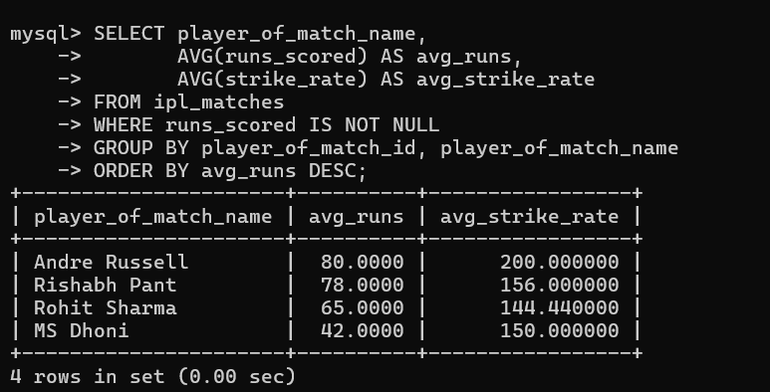

SELECT p.player_name, AVG(bs.runs_scored) AS avg_runs,

MAX(bs.runs_scored) AS highest_score

FROM batting_stats bs

JOIN players p ON bs.player_id = p.player_id

GROUP BY p.player_id

ORDER BY avg_runs DESC;

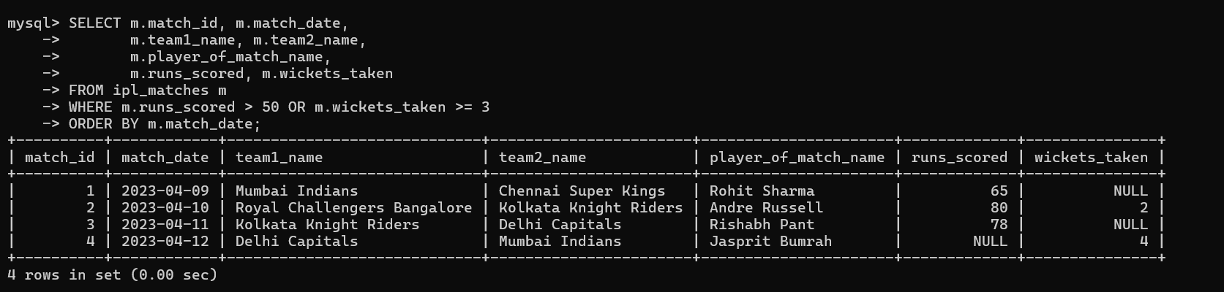

SELECT m.match_id, m.match_date,

t1.team_name AS team1, t2.team_name AS team2,

p.player_name AS player_of_match

FROM matches m

JOIN teams t1 ON m.team1_id = t1.team_id

JOIN teams t2 ON m.team2_id = t2.team_id

JOIN players p ON m.player_of_match_id = p.player_id;

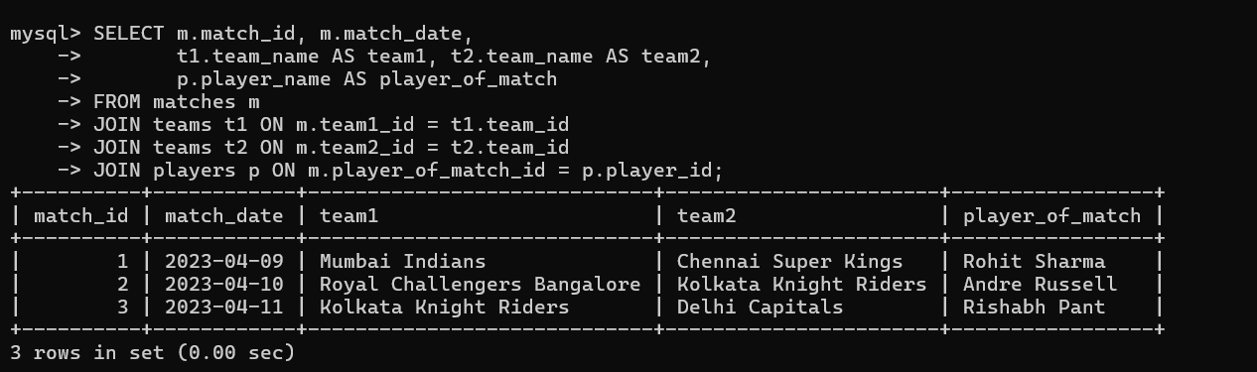

SELECT p.player_name

FROM players p

WHERE p.player_id IN (

SELECT bs.player_id

FROM batting_stats bs

WHERE bs.runs_scored >= 100

);

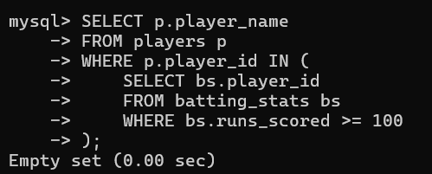

CREATE VIEW match_summaries AS

SELECT m.match_id, m.match_date,

t1.team_name AS team1, t2.team_name AS team2,

tw.team_name AS winner,

CASE

WHEN m.win_by_runs > 0 THEN CONCAT('by ', m.win_by_runs, ' runs')

ELSE CONCAT('by ', m.win_by_wickets, ' wickets')

END AS result,

p.player_name AS player_of_match

FROM matches m

JOIN teams t1 ON m.team1_id = t1.team_id

JOIN teams t2 ON m.team2_id = t2.team_id

JOIN teams tw ON m.match_winner_id = tw.team_id

JOIN players p ON m.player_of_match_id = p.player_id;

